The HIT Fund awards are for Stanford University innovators whose work has progressed towards developing solutions for specific commercial applications. The awards are intended to provide the seed funding for de-risking critical activities that enable technology transfer or securing additional funding from industry or venture capital.
Please submit the completed application as a single PDF file in this format: "PI_Last name.2023.month.day" via email attachment to the HIT Fund team (HITfund2023@stanford.edu) before the submission deadline date of July 15, 2023 at midnight PST.

Eligibility

- Current Stanford students, postdoc, faculty or staff members
- Open to any Stanford school or institute
- Each proposal must have at least one faculty member as a principle investigator (PI)
- The project must have a clearly identifiable innovation component and the intellectual property must have been disclosed to Stanford’s Office of Technology Licensing (OTL)

Examples of activities eligible for funding include, but are not limited to:

- Prototype design & fabrication
- Contract manufacturing for scale-up & delivery of samples
- Customer & market research activities — needs discovery, go-to-market approaches, key partnerships
- Consultants — for technical guidance, market research, regulatory process
- Development of strategies for strengthening the technology's intellectual property portfolio
- Student and postdoc salary and stipends

Award Types and Funding Levels

- Financial Awards:
  - Milestone-based funding up to $250k, typically for up to 12 months. The award amount will be based on the maturity of the project, a detailed budget, and clearly defined critical goals and deliverables.
- Non-monetary Awards:
  - Introductions to industry experts, potential customers, potential partners, and potential investors
  - Access to MBA Interns to help with business planning, customer needs discovery, go-to-market strategies, and creating pitch decks
  - IP strategy and patent mapping
  - Guidance on Stanford and external entrepreneurship programs and resources

Applications for non-monetary support of customer and market research activities, which do not include a financial request, are also encouraged.

Application Review and Selection Process

- Q&A Sessions: The HIT Fund team will be available to answer questions about the Fund, eligibility, and the application during Zoom Q&A sessions. Please sign-up on the HIT Fund website (goto.stanford.edu/HITfund).

- Additional questions: If further help is needed with the Fund application, please email the HIT Fund team (HITfund2023@stanford.edu) to schedule time.

- Review Process:
  - A committee selected from the HIT Fund staff, external advisors, and affiliates provides input in the evaluation of all applications.
  - Review Sessions: Finalists will present to key internal and external advisors.

- Evaluation Criteria: The objective of the HIT Fund is to advance technologies to the point where additional external funding and/or technology transfer is achieved. The following evaluation criteria will be considered during the review process:
  - Technology/solution has the potential to scale and have a societal or economic impact. If unknown, the proposed Statement of Work includes a needs-discovery or product-market fit activity as an early milestone.
  - Demonstrated interest from potential industry partners or customers. If interest has not been established, the proposed Statement of Work includes a discovery activity as an early milestone.
  - Competitive advantage over solutions that are currently available or in development. If unknown, the proposed Statement of Work includes a competitive analysis activity as an early milestone.
  - A demo, prototype, and/or pilot program exists or development is included in the proposed Statement of Work, without which the technology/solution is unlikely to garner interest for technology transfer.
  - Likelihood of success of the proposed technical innovation and project milestones within the budget and award timeframe.
  - HIT Fund expertise and resources are appropriate in addressing the current challenges to commercialization and will meaningfully advance the technology/solution along the commercialization path.

During the Award

For each selected project a Project Advisory Team will be assembled to advise the project team as needed during the funding period:
- Industry mentor and/or domain expert
- HIT Fund Director, HIT Fund Program Manager, OTL Licensing Associate
- IP / Patent attorneys, as relevant
- MBA Intern, as relevant
- Venture Capitalist (Corporate or Financial), as relevant
- Faculty advisors, as relevant

Terms and Conditions of the Award

Inventions and Intellectual Property: Any new IP conceived or generated during the program must be disclosed to the Stanford Office of Technology Licensing (OTL).

Statement of Work (SOW) & Milestones: Each project has a Statement of Work with objective technical and commercialization milestones. Achieving each milestone is a key decision point for assessment of progress and continued funding. Any significant revisions of the SOW and the budget during the award period due to technical or commercial developments must be approved by the HIT Fund.

Alternate Funding: If a project gets funding from additional internal or external sources for the same tasks, the HIT Fund must be informed immediately. Any overlapping funds provided by the HIT Fund may be reallocated to other activities as long as they are directly related to the approved SOW and approved in writing by the HIT Fund.

Publications: The HIT Fund must be cited in all publications and presentations that describe the work supported by the HIT Fund. Copies of all publications containing this acknowledgement must be provided to the HIT Fund.

Program Participation: Awardees may be asked to participate in HIT Fund events throughout the award period.

Reporting requirements may include:

- Monthly calls with appropriate Project Advisors team members regarding business development, industry insights, and VC guidance, as needed
- Quarterly reviews of progress against milestones with HIT Fund personnel
- Notification of achievement of all milestones in Statement of Work
- Half-yearly program reviews with Project Advisory Team for high-level feedback and course correction
- Final report presentation to Project Advisory Team
- Informal reporting on milestones and successes after exiting the HIT Fund

Application

The questions included in the application sections are to guide applicants in understanding the expectations of how they will be evaluated. Please keep the application to 3 to 5 pages in length, in addition to the cover page. NOTE: Please do not include confidential information in this application.

Please submit the completed application as a single PDF file in this format: "PI_Last name.2023.month.day" via email attachment to the HIT Fund team (HITfund2023@stanford.edu) before the submission deadline date of July 15, 2023 at midnight PST.

Applicant Information (Cover Page)

Project Title:

PI/Primary Contact
Name:
Department:
Email:
Phone:

Team members (name, affiliation)

Has the technology / invention been disclosed to Stanford’s Office of Technology Licensing (OTL)?
- Yes. Who is the OTL contact? _________________________________________
- No

What is the docket number(s), if known?

Which one of the following best describes your commercialization plan?
- Create a new company
- Develop the technology so it can be licensed to an existing company
- Have not yet decided

What is the total amount of funding being requested from the HIT Fund?

Which of the following types of additional support are you requesting? Select all that apply.
- Industry mentor and/or domain expert
- Introductions to potential customers, partners, investors
- Patent strategy/patent mapping
- Access to an MBA Intern to assist with research, assessment, and business planning
- Guidance on customer needs discovery, assessing competitive landscape, go-market-strategies, business model, creating pitch decks, and other commercialization activities
- Guidance on Stanford and external entrepreneurship programs and resources
- Other: _________________________________________________

Executive Summary
Briefly describe the problem being addressed and why existing solutions do not address the need. Briefly describe your technology and/or solution, along with its key value proposition(s). Briefly describe the size of the market opportunity. Maximum 200 words.

- Innovation
Describe the core innovation that is fundamental to the solution you intend to provide. Do you expect any additional IP to be generated during the course of this Project, and if so, in what area(s).

- Opportunity
What is the customer need you are addressing and how have you verified it is a true pain point?
Describe the solution you envision will be enabled by your technology. What is the value proposition, e.g. increase in revenue/improved outcomes, cost savings, reduced environmental impact, convenience, or other.
How will the solution be delivered to the customer? Include a brief description of the customer who will buy the product or service.
Briefly summarize the addressable market that these customers represent.

- Competitive Landscape
What are the competitive alternatives and how is your solution advantaged compared to the alternatives?
If possible, include a chart comparing key features of your offering to that of competitors on the market and in development.
Include a summary of the techno-economic analysis, if it has been done. If not, is it a planned milestone during the HIT Fund or after participation in the HIT Fund?

- Technology and Commercialization Timeline
List the major milestones that have been met to date in the development and de-risking of the technology.
List the major milestones planned for the future which already have funding.

- Proposed Approach towards Commercialization — Statement of Work (SOW)
Detail the anticipated milestones and success metrics, along with the timeline, funding, and additional support requested for each milestone. Note that the success metrics must be quantifiable and measurable so it will be obvious if they have, or have not, been successfully met.
Describe how each of the milestones leads to any of the below. Note: Do indicate if any of these have already been completed or if the plan is to complete after participation in the HIT Fund.
(a) a demonstration or validation of the technology and/or its scalability for the proposed commercialization purpose
(b) enables [further] business/market understanding allowing you to determine the path to commercialization including go-to-market strategy and partnerships
(c) enables [further] understanding of customer/market needs to determine the appropriate applications and how you need to tune your existing technology/solution
Detail the requested budget and breakdown of costs for the milestones and deliverables, using the following format or something similar. Indicate if milestones will be executed sequentially or in parallel.
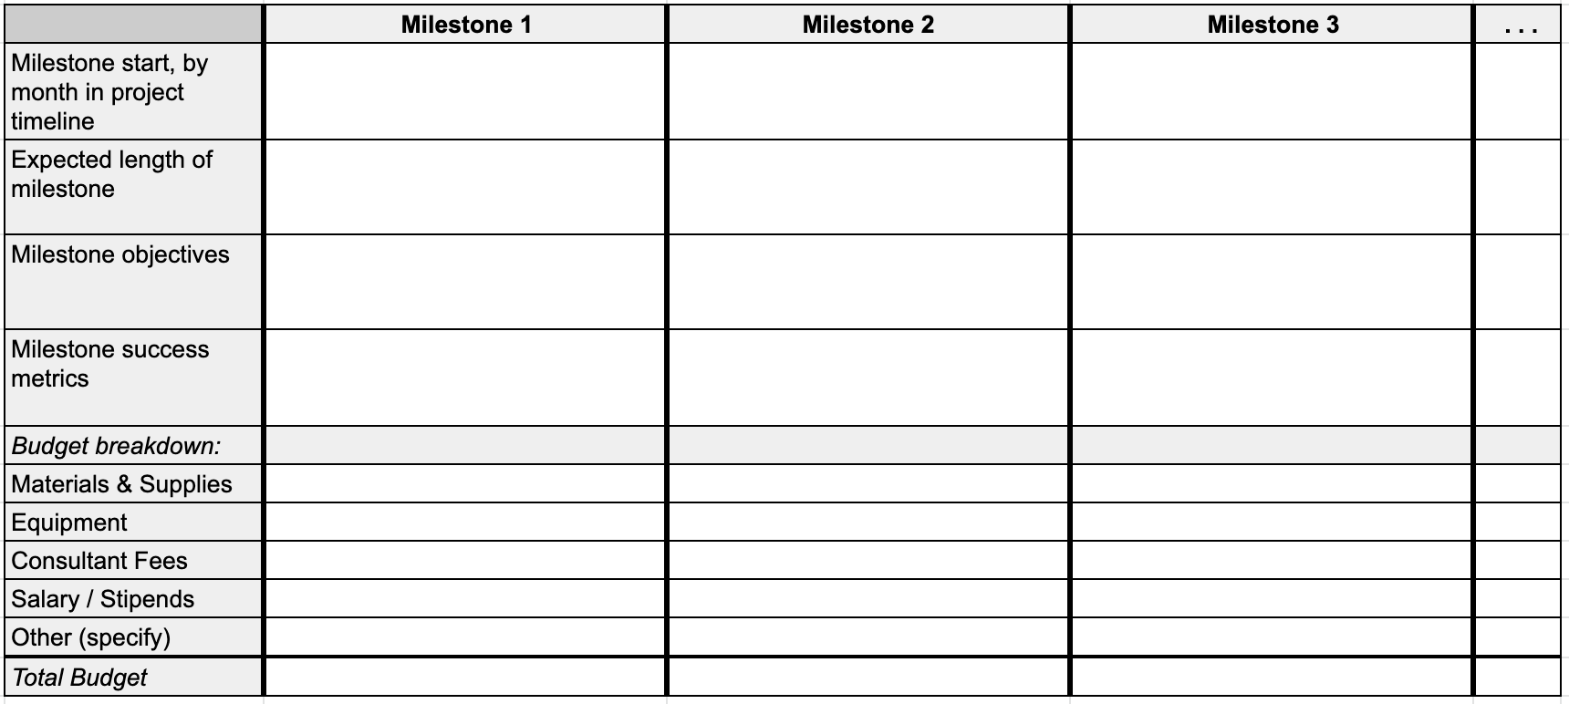
Describe any strategies or expected opportunities for strengthening the technology’s intellectual property portfolio.

Intellectual Property (IP)

Has a patent or patent application or copyright been filed that relates in any way to the work described in your project Statement of Work (SOW), whether by Stanford or any third party? If yes, list the relevant OTL docket numbers, if known.

Please identify all contributors, including yourself, to the work in your SOW. Please also provide all contributors’ affiliation with the Institution, if any, and/or their affiliation with any third parties.

Please list any governmental, educational, charitable or other funding or support relating to the work described in the SOW that has been used to date to develop the project.

Do you plan to collaborate with anyone outside of Stanford to source materials, develop manufacturing methods, or work in a way that could generate IP? If yes, explain.

Other

List the financial and commercialization support received from other Stanford funds, accelerators, and programs.

List the names of external parties with whom you’ve discussed your project and received validation of your approach.

Letters of support or testimonials are helpful but not required. If available, they provide external validation of key components of the application. Useful letters of support include:

Confirms the technology as impactful

Validates a commercial market need

Indicates a specific willingness to assist, partner, fund or license when certain milestones are reached
- Indicates an increased likelihood of commercialization if the milestones funded are achieved

List the names of other researchers at Stanford who are doing work similar to or related to your project.

Bio/resume is NOT required and should not be included.

